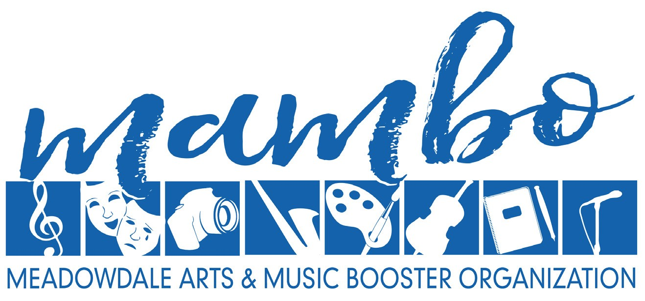

Dear Community Business Owner:

The annual Meadowdale Arts & Music Booster Organization (MAMBO) auction and variety show is February 9th, 2024. This is the largest and most entertaining fundraising effort of the year for MAMBO. The Mambo Auction and Variety Show will be held virtually and will include a week-long silent auction as well as a live virtual event that will include performances from our very talented students as well as examples of the beautiful art being created at Meadowdale. We are reaching out to you for your help in making this event a success.

All funds raised are used to provide enrichment opportunities for Meadowdale High School visual and performing arts students beyond those activities that the school district is normally able to offer, opportunities such as guest artist performances/workshops, field trips, and both supplies and repairs for all our young artists’ endeavors. In past years, the auction funded our general budgets, including thousands of dollars in discretionary spending by our teachers for classroom expenses and to provide need-based scholarships. Thanks to last year’s successful auction we were able to help repair the grand piano, locks for instrument lockers, mic headsets, portable dressing room, storage rack for the LED lighting, pay for camps, recording sessions, venues and so much more. However, our needs are still great!

We anticipate attendance of 150+ at our annual Auction and Variety Show. This is a great opportunity for your business to receive exposure in our Edmonds/Lynnwood community. Businesses who donate will receive recognition on our MAMBO website, school publication and auction website.

There are several ways you can support our arts students, including corporate sponsorship and donation of goods or services, gift cards or gift certificates, themed baskets and event packages for our silent and live auction. Your contributions are IRS tax-deductible. Please be sure to include any marketing materials, brochures, and relevant details about the item(s) you donate – including value of donation - which we will use to write an accurate description for potential bidders.

If you are interested in supporting this event, please contact Jenine Rittierodt at (425)478-9004 or mamboauction@mhsmambo.org. We are happy to pick up items for donation. Please accept our gratitude for your contribution to MAMBO!

Thank you in advance for your support!

Meadowdale Arts & Music Booster Organization
6002 168th St SW Lynnwood, WA 98037

Meadowdale Arts & Music Booster Organization is a non-profit 501(c)(3) corporation, IRS tax ID 91-1240709, as recognized by the Internal Revenue Service and WA Secretary of State.

Please accept our gratitude for your IRS tax-deductible contribution.

