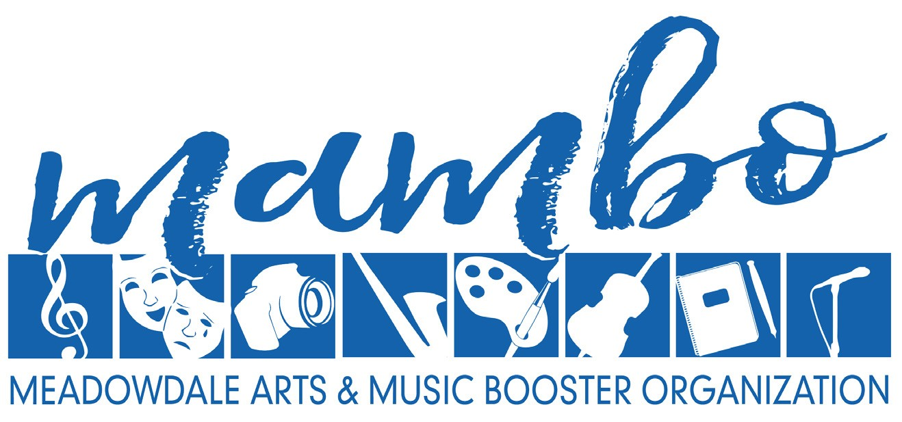

Meadowdale High School Arts & Music Booster Organization Auction

Dear Business Member,

The Meadowdale High School Arts & Music Booster Organization (MAMBO) is reaching out to local businesses to generate support for Meadowdale High School’s creative arts, music and dramatic arts programs. Meadowdale High School is often recognized for our successful arts and music programs, with many of our student participants being awarded various distinctions for their efforts and talents.

The annual Meadowdale Arts & Music Booster Organization (MAMBO) auction and variety show is February 4, 2023. This is the largest and most entertaining fundraising effort of the year for MAMBO. The Mambo Auction and Variety Show will be held virtually and will include a week-long silent auction as well as a live virtual event that will include performances from our very talented students as well as examples of the beautiful art being created at Meadowdale. We are reaching out to you for your help in making this event a success.

Last year, a portion of our funds raised from the auction helped to:
• Buy New Choir Robes.
• Repair and Restore the Theater Audio System.
• Pay for BORCH Camp, Venue for Winterfest, Recording Sessions for Impressions Jazz Choir.
• Buy New Jazz Bass strings, Amps and Cymbals.
• Buy Pottery Wheel Splash Pans and a Cricut plus accessories for Art classes.

Our needs are great. Please consider partnering with us by becoming a MAMBO Corporate Sponsor. There are three specific corporate sponsorship levels to benefit the arts at our annual auction:
• $250 Sponsorship Level: Your business receives recognition during the auction presentation, logo in the auction program, and verbal recognition by the auction MC.
• $500 Sponsorship Level: Your business receives all the above plus logo placement in music programs and playbills throughout the school year.
• $1,000 Sponsorship Level: Your business receives the above, plus logo placement on the MAMBO website and on social media.
We look forward to talking to you soon. If you have any questions in the meantime, please don’t hesitate to email us at mamboauction@mhsmambo.org.
Thank you in advance for your support!

Meadowdale Arts & Music Booster Organization
6002 168th St SW Lynnwood, WA 98037

Meadowdale Arts & Music Booster Organization is a non-profit 501(c)(3) corporation, IRS tax ID 91-1240709, as recognized by the Internal Revenue Service and WA Secretary of State.
Please accept our gratitude for your IRS tax-deductible contribution.

